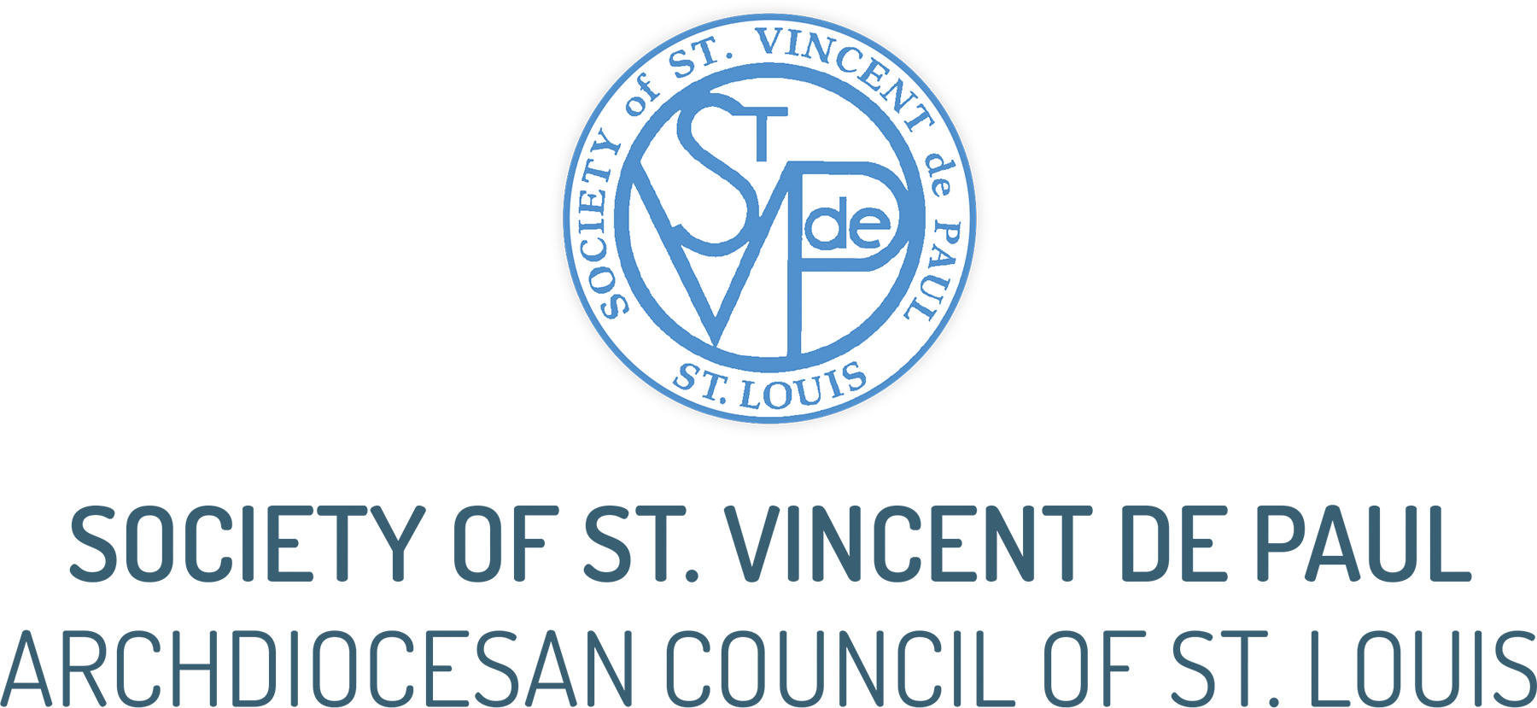

BULLETIN ANNOUNCEMENT SUGGESTIONS

It is also very effective to use personal stories about who you have served (not using names) and how you have been able to help them.

October - December 2021

Oct. 3: Who is The Society of St. Vincent de Paul?
The Society of St. Vincent de Paul in St. Louis is a Catholic lay organization and serves those in need throughout the Greater St. Louis area. The Society consists of more than 3,400 volunteer members belonging to 139 parish-based conferences. In fact, there is a Conference right here at xx Parish! We make home visits to those in need to provide person-to-person services, including arranging utility and prescription drug assistance and assisting with housing and transportation needs. The Society also operates nine Thrift Stores in the St. Louis area.

Last year, the Society assisted more than 260,000 people and provided $14.6 million in direct aid.
Want to learn more or join us? Call 314-881-6075.

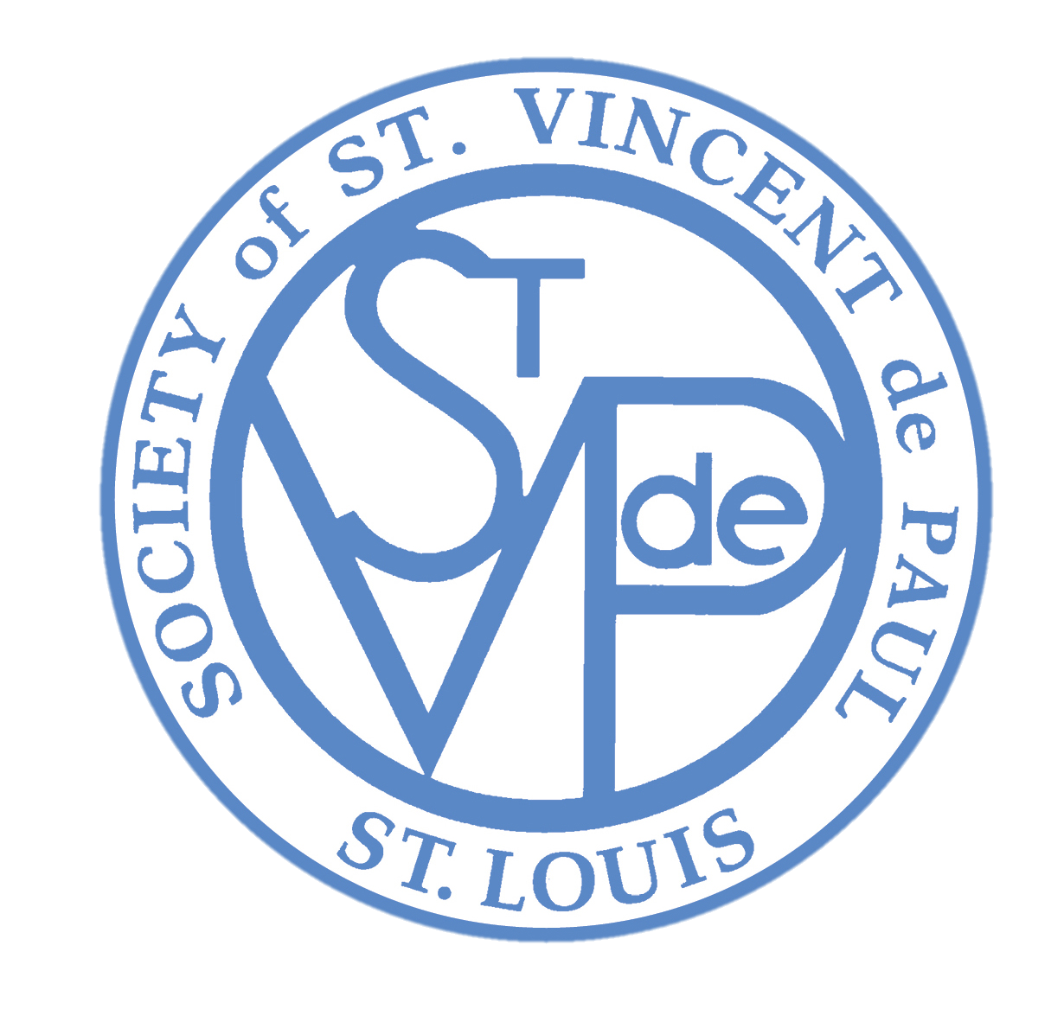

Oct. 10: Help the Society of St. Vincent de Paul!
Donate your vehicle.
Running or not. Free towing. Tax deductible. A vehicle donation from you gives hope to those in need. We have an easy process and free pick-up.
To learn more, call or visit us online. 800-322-8284 or www.svdpusacars.com



Oct. 17: Have you heard His call to help others? It’s time to answer. Join the Society of St. Vincent de Paul and become a Vincentian.
Who is a Vincentian? A Vincentian is a member of the Society of St. Vincent de Paul, one of the largest Catholic lay organizations in the world. Vincentians volunteer in local communities and are from every profession. Vincentians understand that everything that we have—skills, talents, material goods—comes from God, and that we are called as Christians to use those resources to reduce the suffering experienced by our brothers and sisters in need, providing face-to-face contact with those we serve.
Vincentians believe that “no work of charity is foreign to the Society,” and so each local Parish Conference helps people in their area in different ways—assistance with utility bills, rent or mortgage assistance, clothing, furniture, or simply prayer and companionship.
Why be a Vincentian? See Christ in the face of the poor and to bring the love of God to those who are in material or spiritual need. You’ll grow spiritually and make friends.
How to join us? Call 314-881-6075 to learn more.

Oct. 24: Donate your vehicle and Help the Society of St. Vincent de Paul!
Running or not. Free towing. Tax deductible. A vehicle donation from you gives hope to those in need. We have an easy process and free pick-up.
To learn more, call or visit us online. 800-322-8284 or www.svdpusacars.com

Oct. 31: Do you have gently used clothing, home goods or furniture you no longer use? Please consider donating to the Society of St. Vincent de Paul. You give hope to your Neighbors who have nothing.

Find a donation bin here on our Parish parking lot or drop off your items at any St. Vincent de Paul Thrift Store. The closest one to this parish is _________________ on ___________ Rd.
Doorstep or garage pickups are available for furniture. To schedule a furniture pickup, call (314) 881-6006 or e-mail donations@svdpstl.org.



NOVEMBER 2021

Nov. 7: It’s St. Vincent de Paul Sunday!
What is the Society of St. Vincent de Paul?
The Society of St. Vincent de Paul is an international Catholic lay organization dedicated to providing service to those in need. We help in a variety of ways . . . Housing, clothing and food, utility and prescription drug assistance, vehicle repairs and more.
There are ways you can help . . .
- Join our team of volunteers right here in our parish. You’ll make friends, grow spiritually, and do incredible things. To find out how, talk to a Vincentian or call 314-881-6075.
- Donate. We’ll be collecting in the back of church as you leave mass today. Your help can make a life-changing difference for someone who needs your help.
- Shop at one of our nine St. Vincent de Paul Thrift stores. The closest one to this parish is _________________ on ___________ Rd. Or donate clothing, furniture or household goods.

Nov. 14: What you did for the least of my brothers

Jesus tells us in the Gospel of Matthew . . . “For I was hungry and you gave me food, I was thirsty and you gave me drink, I was a stranger and you welcomed me, I was naked and you clothed me, I was sick and you visited me, I was in prison and you came to me.’ Then the righteous will answer him, saying, ‘Lord, when did we see you hungry and feed you, or thirsty and give you drink? And when did we see you a stranger and welcome you, or naked and clothe you? And when did we see you sick or in prison and visit you?’ And the King will answer them, ‘Truly, I say to you, as you did it to one of the least of these my brothers, you did it to me.’” Matthew 25:35-40

If you’ve been blessed with the ability to give a helping hand to another neighbor in need today, please consider a gift to the Society of St. Vincent de Paul. (Add here how to donate in your parish.)
Your gift will help neighbors facing some of the toughest times of their lives. God bless you for doing what you can for them by giving today!
Nov. 21: You make a real difference to families in need, right here in our parish!
Today as we celebrate Christ the King, may we open the door of our heart so wide that we may listen to the voice of Jesus calling us to help build his kingdom here on earth.
This month, through your gifts, the Society of St. Vincent de Paul was able to bring God’s kingdom of love and mercy to families, providing in food, for utility, rent and other bills.
God Bless You!
Nov. 28: As we begin Advent we are called to “wait” in joyful anticipation for the grace of Christmas to once again bless our lives. Wherever you live in our parish, there are poor families within walking distance of your home. When in need, they ring the rectory bell. They are, in effect, ringing your doorbell.

You can help our Neighbors in Need. Your gift to the Society of St. Vincent de Paul will help the poor celebrate the grace of God’s love this Christmas. Donate right here in our parish or online at www.svdpstlouis.org/donate

DECEMBER 2021

Dec. 5: In today’s Gospel John the Baptist urges us to “Prepare the way of the Lord,” and this is what Advent is all about. We are called to help prepare the way of the Lord by making the real meaning of Christmas come alive in our own hearts, in our family and to reach out to those in need.

Is there a family you know who needs assistance? Let us help. Please call 2-1-1 to reach the Society of St. Vincent de Paul so that together we can help the suffering and poor to celebrate Christmas.

Dec. 12: Are you already thinking about New Year resolutions?

Have you heard Jesus’ call to help others?
Join the Society of St. Vincent de Paul and become a Vincentian.
Who is a Vincentian?
A Vincentian is a member of the Society of St. Vincent de Paul, one of the largest Catholic lay organizations in the world. Vincentians volunteer in local communities and are from every profession. Vincentians understand that everything that we have—skills, talents, material goods—comes from God, and that we are called as Christians to use those resources to reduce the suffering experienced by our brothers and sisters in need, providing face-to-face contact with those we serve.
Vincentians believe that “no work of charity is foreign to the Society,” and so each local Parish Conference helps people in their area in different ways—assistance with utility bills, rent or mortgage assistance, clothing, furniture, or simply prayer and companionship.
Why be a Vincentian?
See Christ in the face of the poor and to bring the love of God to those who are in material or spiritual need. You’ll grow spiritually and make friends.
How to join us?
Call 314-881-6075 to learn more.

Dec. 19: Help the Society of St. Vincent de Paul!
Donate your vehicle. There may be tax benefits for you!
Running or not. Free towing. Tax deductible. A vehicle donation from you gives hope to those in need. We have an easy process and free pick-up.
To learn more, call or visit us online. 800-322-8284 or www.svdpusacars.com

Dec. 26: Today is the feast of the Holy Family of Jesus, Mary and Joseph, and so we can celebrate that we all belong to the holy family of God which makes us brothers and sisters to each other.
At Christmas this year, through your gifts, the Society of St. Vincent de Paul was able to bring the joy and hope to our “brothers and sisters” who are poor by assisting families, providing in food, in gifts, and for utility and rent bills. Thank you!

