Conference Guidelines for Submitting a Request for Council Programs Using ServWare

Due to the volume of requests received for Council Program assistance and the variety of Notes fields in ServWare, it is requested that these guidelines be followed to provide consistency of requests to expedite their processing by the Council staff.

- Upload the completed documents specified in the Council Program Handbook to “Files” in the NIN’s ServWare record. Please ensure uploaded documents are legible and use the standardized file descriptions shown below, as applicable, including the date in the file description:

Council Program Form P. 1 - Date | Landlord W9 - Date | Lease P.1 - Date
Council Program Form P. 2 - Date | Vendor W9 - Date | Lease Signatures - Date
Note: NIN IDs (e.g., Driver’s license) should no longer be submitted with a Council request.

- On the Assistance Request screen (Figure 1), in the “Visit Notes” field, enter the NIN’s Story/Reason(s) necessitating assistance. Note: When the NIN’s Story is entered here, it does not need to be repeated on the Council Program Form, rather write: “See ServWare Visit Note.” A fillable Council Program Form is available on the Council website (www.SVDPSTL.org) under Vincentians > SVdP St. Louis Handbook and Forms. Password: Vincent

- On the Assistance Item screen (Figure 2), in the “Notes” field, enter:

  - A description of what is being requested from the Council (e.g., Requesting Council Utility/Housings/etc. Assistance for $X), and
  - The amount the Conference is paying toward this request.

- Send an email from within ServWare to the Council (see Figure 3 for example)
  - Click on the blue envelope on the upper right of the Assistance Request Screen to open the emailer.
  - Click on the “Select Recipients” field and from the dropdown enter “RequestCouncilProgram” and your Conference ServWare users that should receive a copy of the email, e.g., Conference Treasurer.
  - In the “Custom Subject Line” field enter the Council program assistance that is being requested, e.g., Utility, Housing Assistance, etc.
  - In the “Message” field enter a brief description of the request.

Council staff will reply to the request email, first notifying you of the staff member assigned to the request, and subsequently with its decision.

Adopted Council ServWare Steering Committee 12/2/2020

Figure 1 – Assistance Request Screen

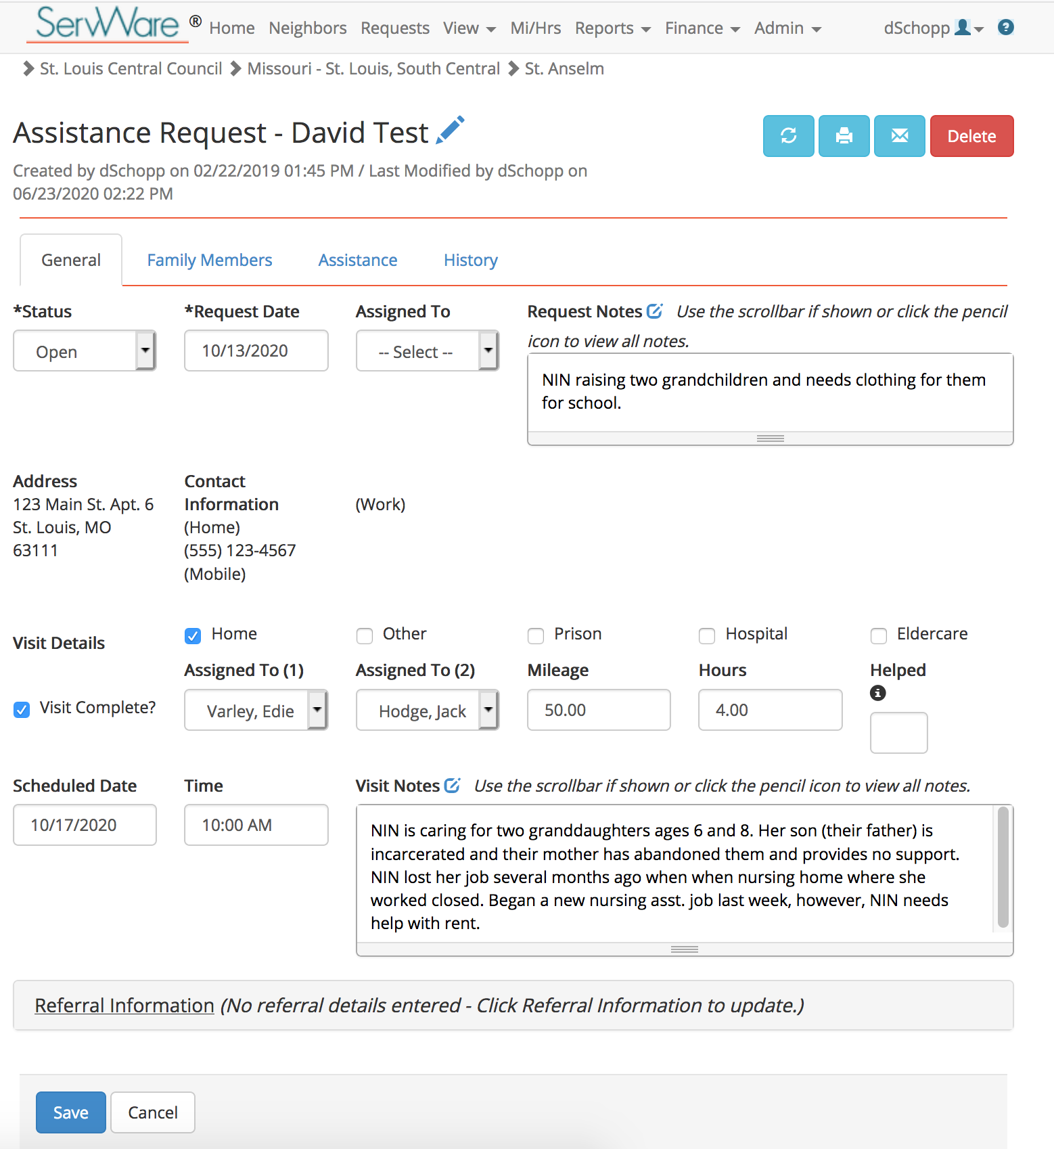

Figure 2 – Assistance Item Screen

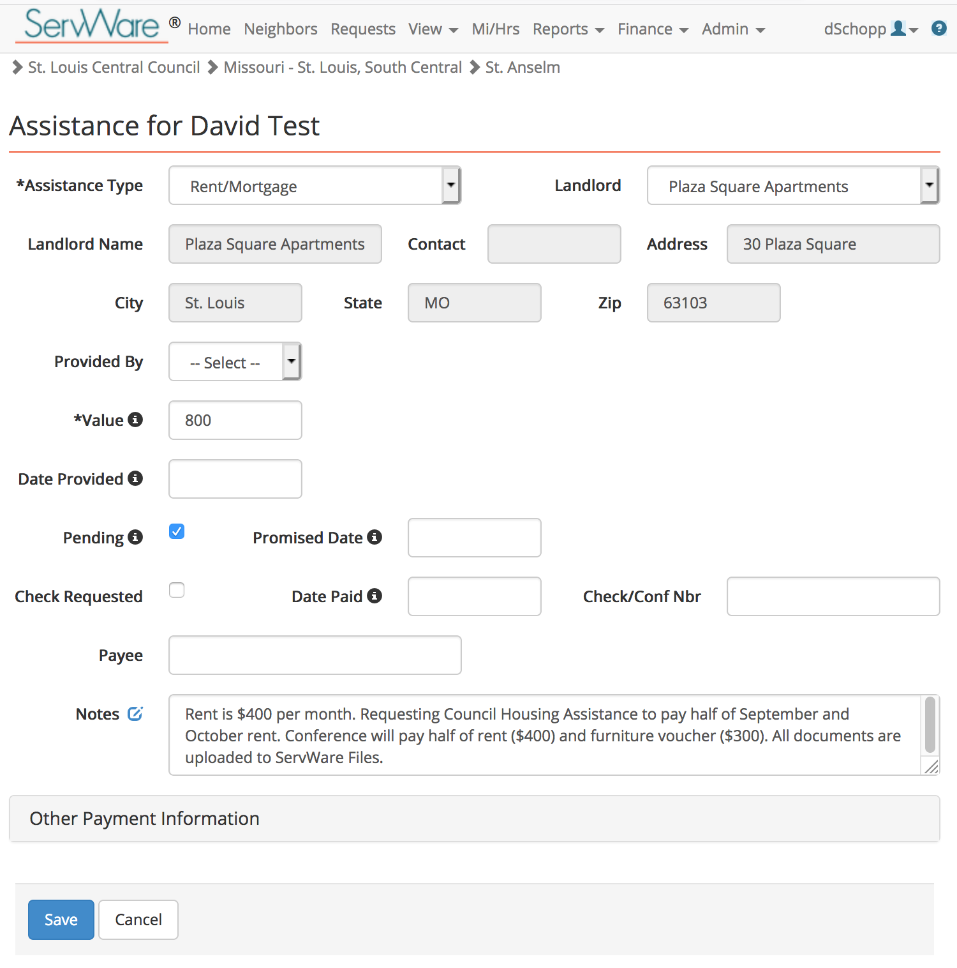

Figure 3 – ServWare Emailer

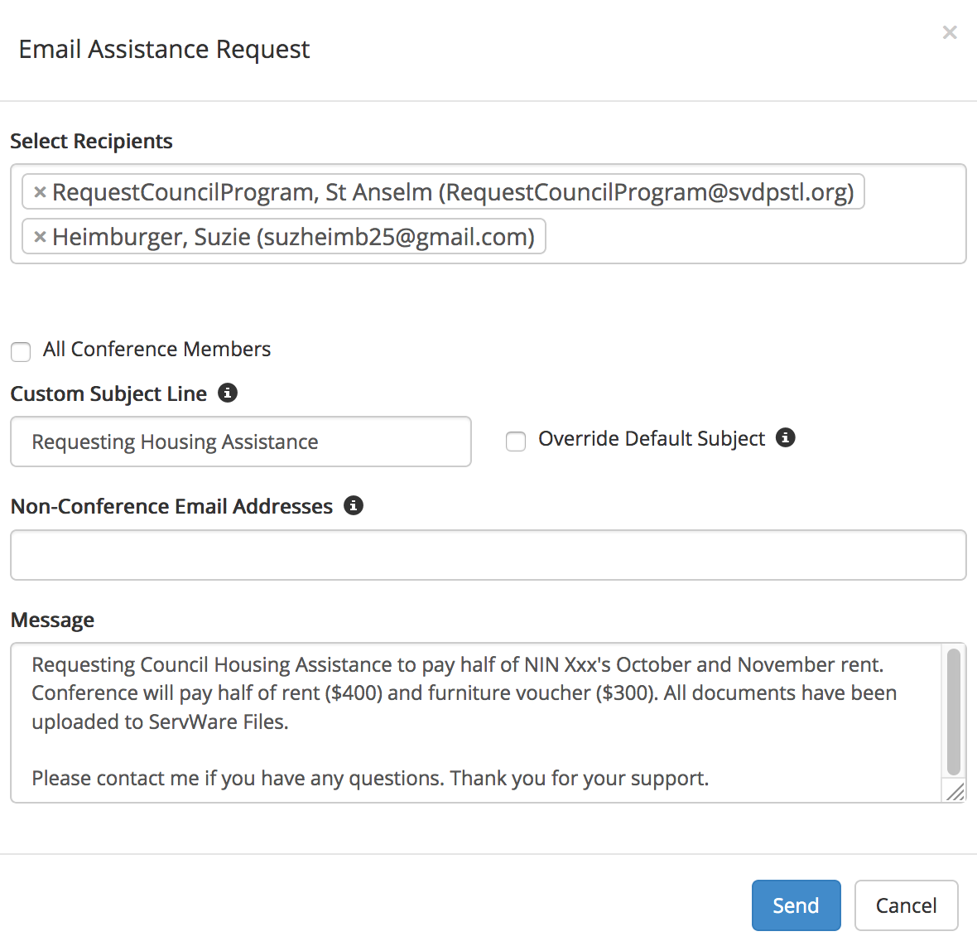

Notes for ServWare Conference Administrators

Entering RequestCouncilProgram@svdpstl.org Into ServWare Email Dropdown

To enter RequestCouncilProgram@svdpstl.org into your Conference’s ServWare Email dropdown go to Admin > Conference Members > New Member and enter the following:
- First Name: Your Conference Name
- Last Name: RequestCouncilProgram
- User Name: RCP followed by Your Conference Name and Your City’s Initials
- Check the box: “Active in ServWare?”
- Email: RequestCouncilProgram@svdpstl.org
- Check the box: “Display in ServWare selection lists”

See example below.

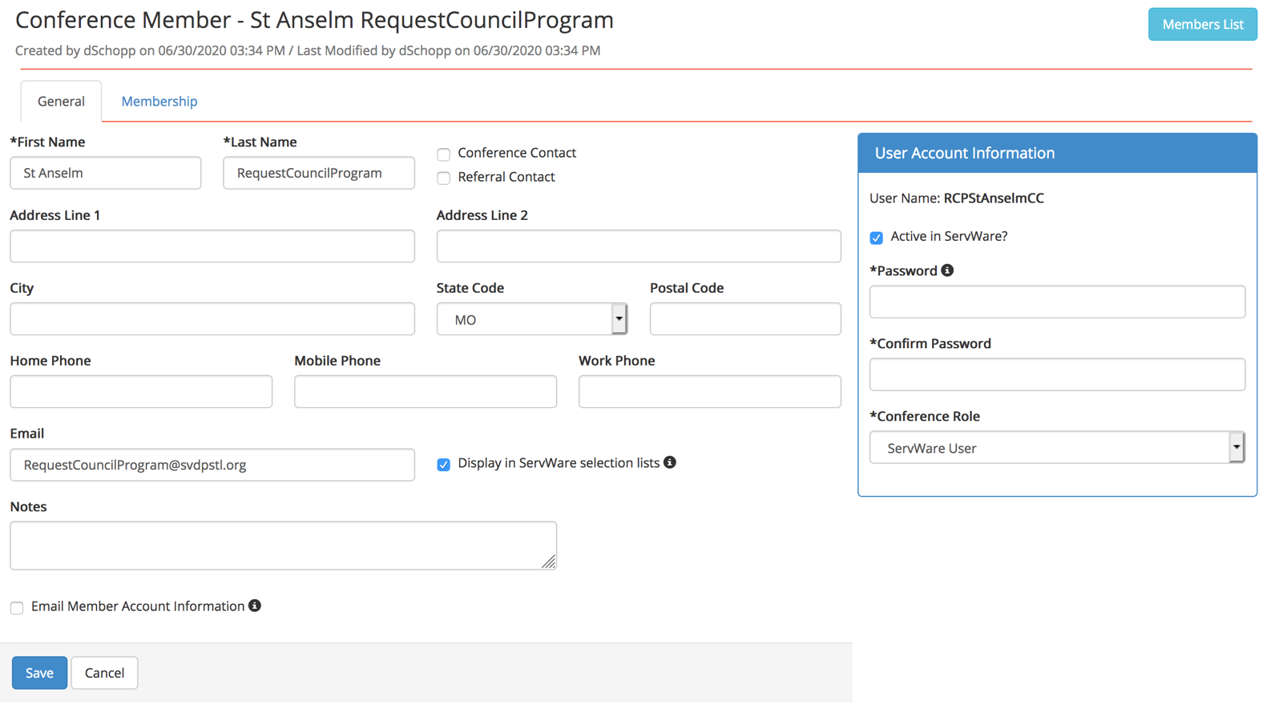

Other Notes
- ServWare has a 4MB size limit for a document uploaded to “Files” in a NIN’s record. To upload larger documents a file compression software, like smallpdf.com, can be used. Most frequently uploaded files are in a pdf or jpeg format. Avoid uploading text or html files.
- It is recommended that the ServWare Conference Administrator, or other designee, at minimum initially review the ServWare entries of NIN records requesting Council Program assistance to ensure consistency with these guidelines in order to avoid delays in processing of a request.
- Questions? Contact your District Liaison or Dave Schopp, Council ServWare Steering Committee member, at davidschopp16@gmail.com.

