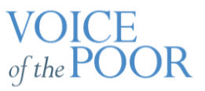

Membership List. March 7, 2022

Mike Carroll, Ascension
Don Doherty, St. Joseph - Clayton
John Fallah, St. Angela Merici
Barbara Galli, Our Lady of Providence
Mike Jarvis, Mary Mother of the Church
Peggy Keilholz, Seven Holy Founders
Prudence Kramer, St. Margaret of Scotland
Mary Kreienkamp, St. Clement of Rome
Jack Krings, Our Lady of Lourdes
Vince O'Connell, St. Margaret Mary Alacoque
Vickie Rainey, St. Elizabeth, Mother of John the Baptist
Bernie Sammons, St. Clare of Assisi
Jean Sandifer, St. Clement of Rome
Dan Schlafly, Our Lady of Lourdes
Deborah Washington, St. Elizabeth, Mother of St. John the Baptist
Jim Wilson, St. Gabriel

