May 2022
Society Scoop
The Unaffordability of Housing
As Vincentians, we daily encounter Neighbors in Need who struggle to retain the housing that they have. Out of Reach 2021, a publication of the National Low Income Housing Coalition (NLIHC), examines why even modest housing remains out of reach for low-income workers.
NLIHC defines the “Housing Wage” as the full-time hourly wage a household must earn to afford a modest rental home at HUD’s Fair Market Rent (FMR) while spending no more than 30% of their income on housing costs. Nationally, the 2021 Housing Wage was $24.90 per hour for a modest 2-bedroom rental and $20.40 per hour for a modest 1-bedroom rental.
Astoundingly, 11 of the 20 largest occupations in the U.S. pay less than the housing wage. Full-time workers in these occupations must, on average, spend more than 30% of their wages—often far more—to rent a modest apartment.
11 OF THE 20 LARGEST OCCUPATIONS IN THE U.S. PAY LESS THAN THE HOUSING WAGE
Two-Bedroom Housing Wage | $ 24.90
One-Bedroom Housing Wage | $ 20.40
Secretaries and Administrative Assistants | $ 20.22
Motor Vehicle Operators | $ 20.02
Financial Clerks | $ 19.51
Other Office and Administrative Support Workers | $ 17.69
Information and Record Clerks | $ 17.41
Material Moving Workers | $ 15.15
Building Cleaning and Pest Control Workers | $ 13.99
Home Health and Personal Care Aides; and Nursing Assistants, Orderlies, and Psychiatric Aides | $ 13.94
Cooks and Food Preparation Workers | $ 13.35
Retail Sales Workers | $ 12.95
Food and Beverage Serving Workers | $ 11.87
Source: National Low Income Housing Coalition. (2021). Out of Reach 2021, p. 5.
https://nlihc.org/sites/default/files/oor/2021/Out-of-Reach_2021.pdf.

The Voice of the Poor Committee, National Council of the United States, has two position papers that speak to this situation. In its Position Statement on Affordable Housing for the Poor, the Voice of the Poor Committee, National Council of the United States, “encourages the Society to speak in a unified voice in support of affordable housing locally, regionally, nationally and internationally” and offers recommendations for an affordable housing policy. In its Position Statement on Fair Wages, the Committee urges Vincentians to tell the stories of those we visit, to encourage our Catholic employers—indeed all employers—to treat their employees fairly, and to support and encourage programs that train workers so that they can participate in the job market to the fullest of their ability. In our home visits, let’s ask our Neighbors, “What is your dream job and what is keeping you from it?” It may be an obstacle that we can work with the Neighbor to clear.
Our own Voice of the Poor Committee, Archdiocesan Council of St. Louis, welcomes and encourages your feedback on how best to advocate for full employment and affordable housing for our Neighbors in Need. Contact us at vopstlouis@gmail.com and share the insight you’ve gained from your service to our Neighbors.

Facebook
The “Housing Wage” is the full-time hourly wage a household must earn to afford a modest rental home at HUD’s Fair Market Rent (FMR) while spending no more than 30% of their income on housing costs. Nationally, the 2021 Housing Wage was $24.90 per hour for a modest 2-bedroom rental and $20.40 per hour for a modest 1-bedroom rental. Astoundingly, 11 of the 20 largest occupations in the U.S. pay less than the housing wage. Full-time workers in these occupations must, on average, spend more than 30% of their wages—often far more—to rent a modest apartment. For more info, see Out of Reach 2021, a publication of the National Low Income Housing Coalition, at https://nlihc.org/sites/default/files/oor/2021/Out-of-Reach_2021.pdf.
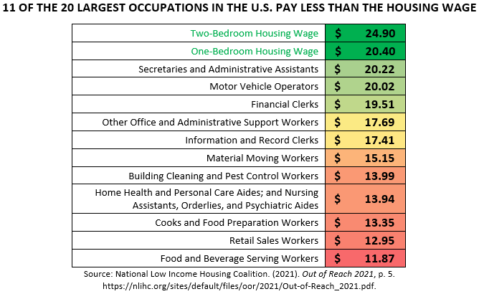

Bulletin
11 OF THE 20 LARGEST OCCUPATIONS IN THE U.S. PAY LESS THAN THE HOUSING WAGE
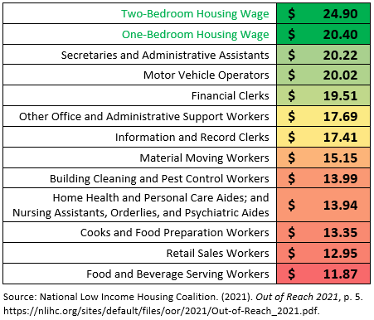
The “Housing Wage” is the full-time hourly wage a household must earn to afford a modest rental home at HUD’s Fair Market Rent (FMR) while spending no more than 30% of their income on housing costs.
Nationally, the 2021 Housing Wage was $24.90 per hour for a modest 2-bedroom rental and $20.40 per hour for a modest 1-bedroom rental.
Eleven of the twenty largest occupations in the United States pay less than the wage needed to afford modest housing.
Your donations to the Society of St. Vincent de Paul assist workers when unforeseen expenses put their housing in jeopardy.

.

June 2022
Society Scoop
The Housing Situation in Missouri
As Vincentians, we daily encounter Neighbors in Need who struggle to keep a roof over their heads. The housing statistics for our Archdiocese and for Missouri as a whole underscore this struggle:
In the Archdiocese of St. Louis:
- The HUD fair market rate for a modest 2-bedroom rental ranges from $662 in less populated areas to $938 in the greater St. Louis metro.
- The income needed to afford a modest 2-bedroom rental ranges from $26,480 annually ($12.73 hourly) to $37,520 annually ($18.04 hourly).
- 1.2 to 1.8 full-time jobs at minimum wage are needed to afford a modest 2-bedroom rental.¹
In Missouri:
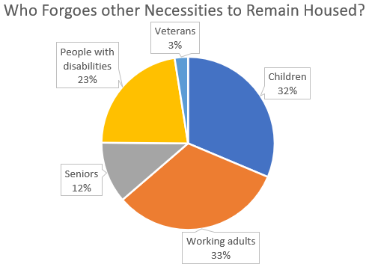
- 345,000 low-income Missouri renters pay over half their income in rent. Rent is considered unaffordable if it costs more than 30% of a household’s income. These Missourians must often forgo other necessities like food and medicine in order to remain housed.
- 34,030 Missouri schoolchildren live in unstable housing—on the street, in shelters, with other families, or in motels.
- 6,530 Missourians experienced homelessness on a single night in 2020.²
In its Position Statement on Affordable Housing for the Poor, the Voice of the Poor Committee, National Council of the United States, calls on Vincentians to encourage the preservation and production of quality housing for low-income families, the elderly, and other vulnerable people; work with other interested groups on affordable housing; and speak out in favor of increasing the number of rent subsidy programs.
There are programs available now that can help our Neighbors in Need who are facing a housing crisis. For guidance on applying for State Assistance for Housing Relief (SAFHR), please see this video of a Vincentian SAFHR meeting. The Society of St. Vincent de Paul, Archdiocesan Council of St. Louis, also offers a Housing Assistance program and Rapid Rehousing program.
Our St. Louis Voice of the Poor Committee welcomes and encourages your feedback on how best to advocate for affordable housing for our Neighbors in Need. Contact us at vopstlouis@gmail.com and share the insight you’ve gained from your service to our Neighbors.
¹ National Low Income Housing Coalition. (2021). Out of Reach 2021. Retrieved February 22, 2022, from https://nlihc.org/sites/default/files/oor/2021/Out-of-Reach_2021.pdf.
² Center on Budget and Policy Priorities. (2022, January 19). Federal Rental Assistance Fact Sheets. Retrieved February 22, 2022, from https://www.cbpp.org/research/housing/federal-rental-assistance-fact-sheets#MO.

Facebook
Housing is considered unaffordable if it costs more than 30% of a household’s income. In Missouri, 345,000 low-income renters pay over half their income in rent. These Missourians often forgo other necessities like food and medicine to remain housed. The Society of St. Vincent de Paul has programs to help our Neighbors in Need who are struggling with their rent and utility bills. For the ways we help, please see https://svdpstlouis.org/what-we-do/assistance-programs.
For more information about the plight of low-income renters in Missouri, please see the Center on Budget and Policy Priorities Fact Sheet at https://www.cbpp.org/research/housing/federal-rental-assistance-fact-sheets#MO.

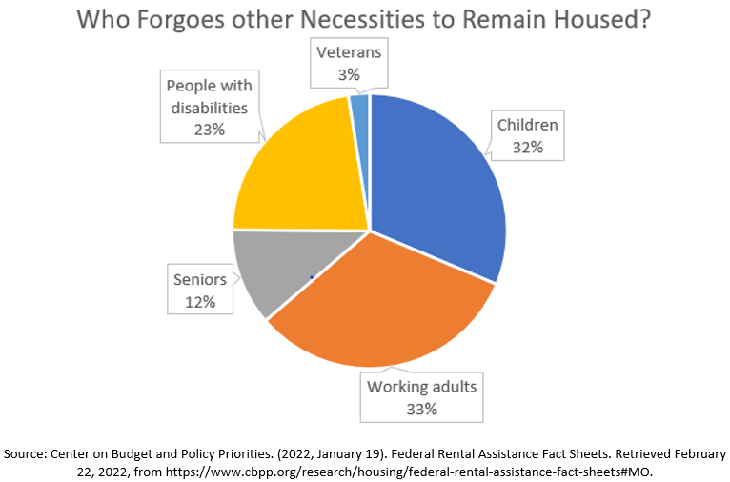

Bulletin
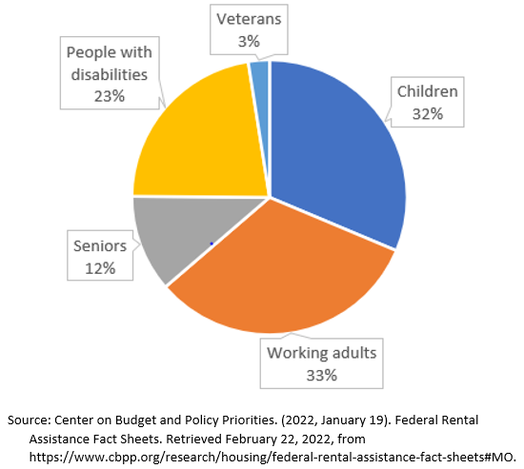
Who Forgoes other Necessities to Remain Housed?
Housing is considered unaffordable if it costs more than 30% of a household’s income.
According to the Center on Budget and Policy Priorities, 345,000 low-income renters in Missouri pay over half their income in rent. These Missourians often forgo other necessities like food and medicine to remain housed.
The Society of St. Vincent de Paul has programs to help our Neighbors in Need who are struggling with their rent and utility bills. For the ways we help, please visit svdpstlouis.org.

