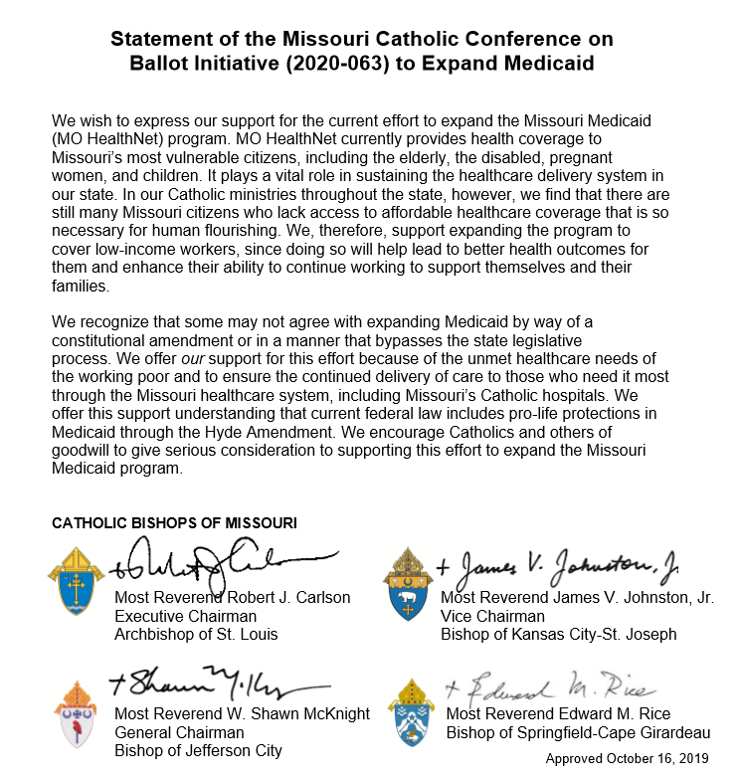

There is a signature campaign currently in progress to get Medicaid Expansion on the November 2020 ballot. If you are interested in helping to gather signatures or would like more information on Medicaid Expansion, please contact Dianne Marshak at 314-302-0595.

