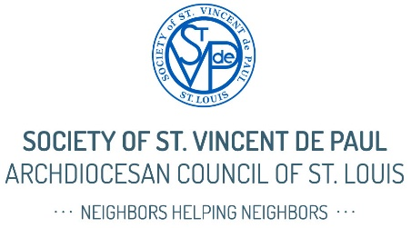
Sample Bulletin Submission for SVdP Sunday, November 2
Today is SVdP Sunday
The Society of St. Vincent de Paul is quietly but powerfully at work in our parish and throughout the St. Louis region.
You may know SVdP from our Thrift Stores or for helping with rent, utilities, food, or furniture—but that’s only part of the story.
At its heart, SVdP is a Catholic lay ministry focused on spiritual growth through service. Vincentian volunteers—people just like you—offer person-to-person help to neighbors in need. We visit them in their homes, listen with compassion, and offer assistance rooted in dignity and love.
Today, there are over 2,600 Vincentians serving in 100+ Catholic parishes across St. Louis. Would you consider joining us?
Here’s how you can help:
- Pray for those in need and for those who serve them.
- Join us—SVdP offers a beautiful way to live your faith more deeply.
- Donate to today’s special collection—every dollar stays local and makes a difference.
- Shop or give to our Thrift Stores. Your donations support vital services in our region.
As Jesus said in Matthew 25: “Whatever you did for one of the least of these, you did for me.”
To learn more or get involved, [visit our table after Mass / contact the parish office / see the bulletin insert, call].
Thank you for supporting the mission of the Society of St. Vincent de Paul.

