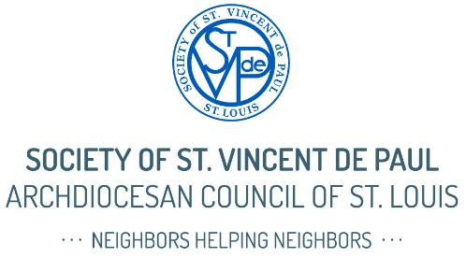

SVdP Sunday Pulpit Talk DRAFT – November 2, 2025
(Approximately 2–3 minutes)
Good morning.
Today is SVdP Sunday—and I’d like to take just a few minutes to share how the Society of St. Vincent de Paul is quietly but powerfully at work right here in our parish and across the St. Louis region.
You may know us from our Thrift Stores, or maybe you've heard that we help people with rent, utilities, food, and furniture. All of that is true—but it’s only the surface.
At the heart of the Society is a mission that's deeply Catholic: we grow spiritually by serving our neighbors in need. We’re not social workers—we’re Vincentians. Volunteers. Regular parishioners like you and me who are called to bring hope to those who are struggling.
The most important thing we do is simple—but rare: We listen.
We visit people in their homes and meet them where they are—physically, emotionally, and spiritually.
We hear their stories, not just their problems. And when we can help—whether it’s with food, rent, clothing, or simply encouragement—we do it person to person, in love and in faith.
Right now, there are more than 2,600 Vincentians serving in over 100 Catholic parishes across the St. Louis area. And we’re asking you to consider joining us—because there’s always room for another heart willing to serve.
So—how can you help?
1. Pray. Pray for our neighbors who are struggling, and for the Vincentians who serve them.
2. Join us. If you’ve been feeling a nudge to do more—to live your faith more fully—this is your invitation. SVdP offers a way to help others while growing closer to God.
3. Donate. Today’s second collection, or the donation basket after Mass, goes directly to helping people in need right here in our parish boundaries. Every dollar makes a difference.
4. Shop or give. Support our mission by shopping at or donating to our St. Vincent de Paul Thrift Stores. Your donations help fund vital programs that help Neighbors in Need.
(Continued, next page)
In Matthew 25, Jesus said: “Whatever you did for one of the least of these brothers and sisters of mine, you did for me.”
That’s the spirit behind everything we do at St. Vincent de Paul.
If you'd like to learn more or get involved, please stop by [our table after Mass / see me after Mass / check the bulletin]. We would love to welcome you.
Thank you, and may God bless you.

